Operating Systems and Computer Graphics Project

CPU Scheduling Visualization Using Gantt Charts

Course:

Operating systems And Computer Graphics

Team Members:

- Kenzy Mohammed Ayman - 24030206

- Moataz Saleh Mohamed - 24030065

Project Objective

The objective of this project is to implement and visualize different CPU scheduling algorithms used in Operating Systems.
These algorithms help manage how processes are executed by the CPU efficiently.

In this project, we developed a Python-based application that simulates scheduling techniques and displays their execution using Gantt charts for better understanding and visualization.

------------------------------------------------------------------------------------

Algorithms Implemented

The following scheduling algorithms were implemented:

- First Come First Serve (FCFS):
Processes are executed in the order they arrive.

- Shortest Job First (SJF):
Processes with the shortest burst time are executed first.

- Round Robin (RR):
Each Process is given a fixed time slice (quantum) and executed in cycles until completion.

------------------------------------------------------------------------------------

Tools and Technologies Used

- Python - for implementing scheduling logic.

- Matplotib - for generating Gantt charts (visualization)

- Visual Studio Code - as the development environment.

------------------------------------------------------------------------------------

How the Application Works

- The user defines the processes with:
- Arrival time
- Burst time

- The program applies each scheduling algorithm:
- FCFS
- SJF
- Round Robin

- Execution order and timing are calculated.

- A Gantt chart is generated for each algorithm showing:
- Process execution timeline
- Start and finish times

- In Round Robin scheduling, processes may appear multiple times because they are executed in time slices until they finish.

------------------------------------------------------------------------------------

Results and Visualization

The application successfully generates Gantt charts for all scheduling algorithms.
These charts illustrates how processes are executed over time and highlight the differences between each scheduling technique.

Figure (1) Figure (2)
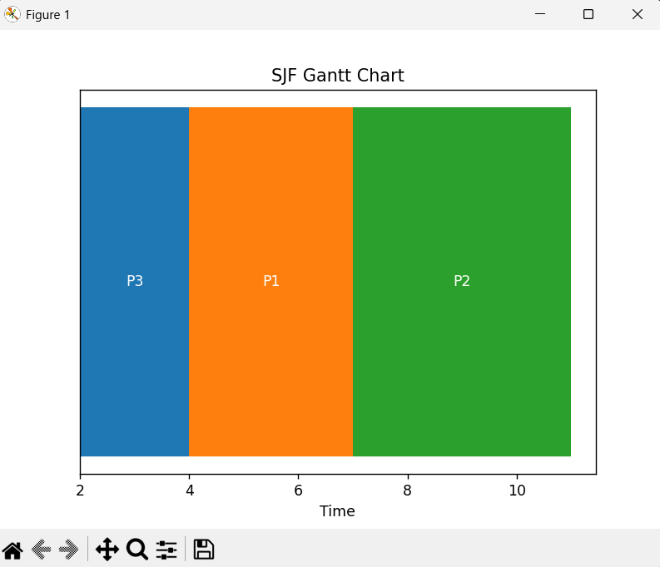
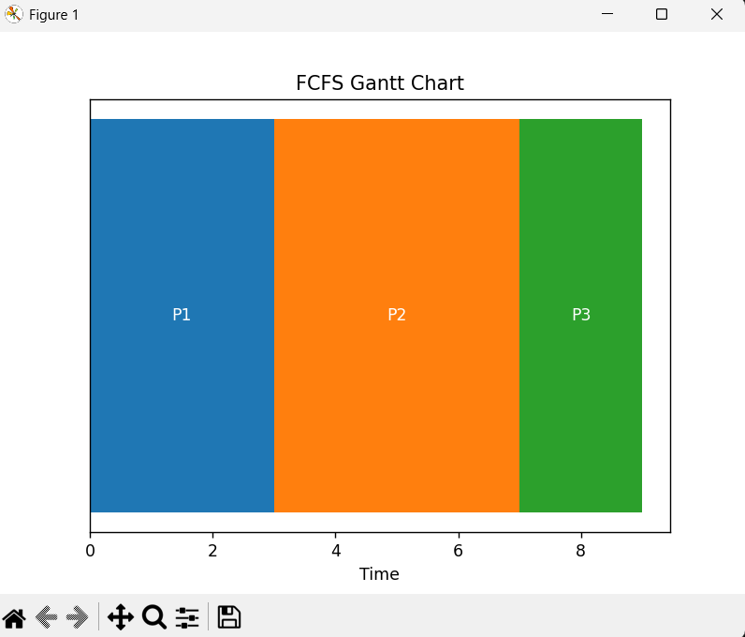

Figure (3)

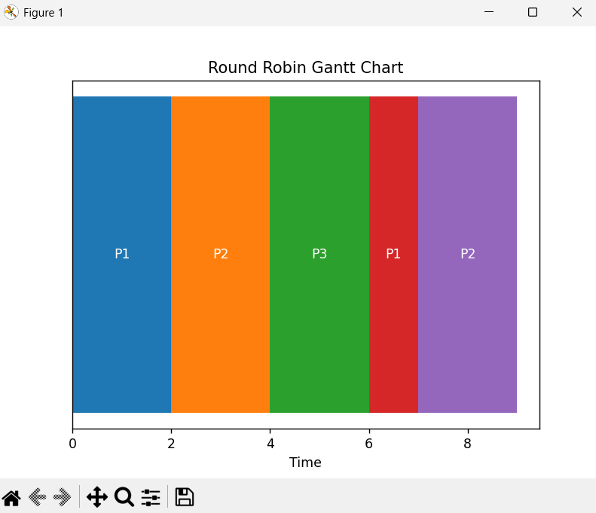

Conclusion

The project demonstrates how CPU scheduling algorithms work in operating systems and how they impact process execution.

By combining operating systems concepts with computer graphics, we created a visual and interactive way to understand scheduling techniques. The use of Gantt charts makes it easier to analyze and compare different algorithms.

